Exercise 8 – Aggregate SQL Functions

The exercises in this lab will be based on the same ERD we have been using for the past few exercises.

Remove all tables from your database schema and run the script book_shop_data.sql files to create the tables below. You may use the book_shop_cleanup.sql to remove the tables when you are done.

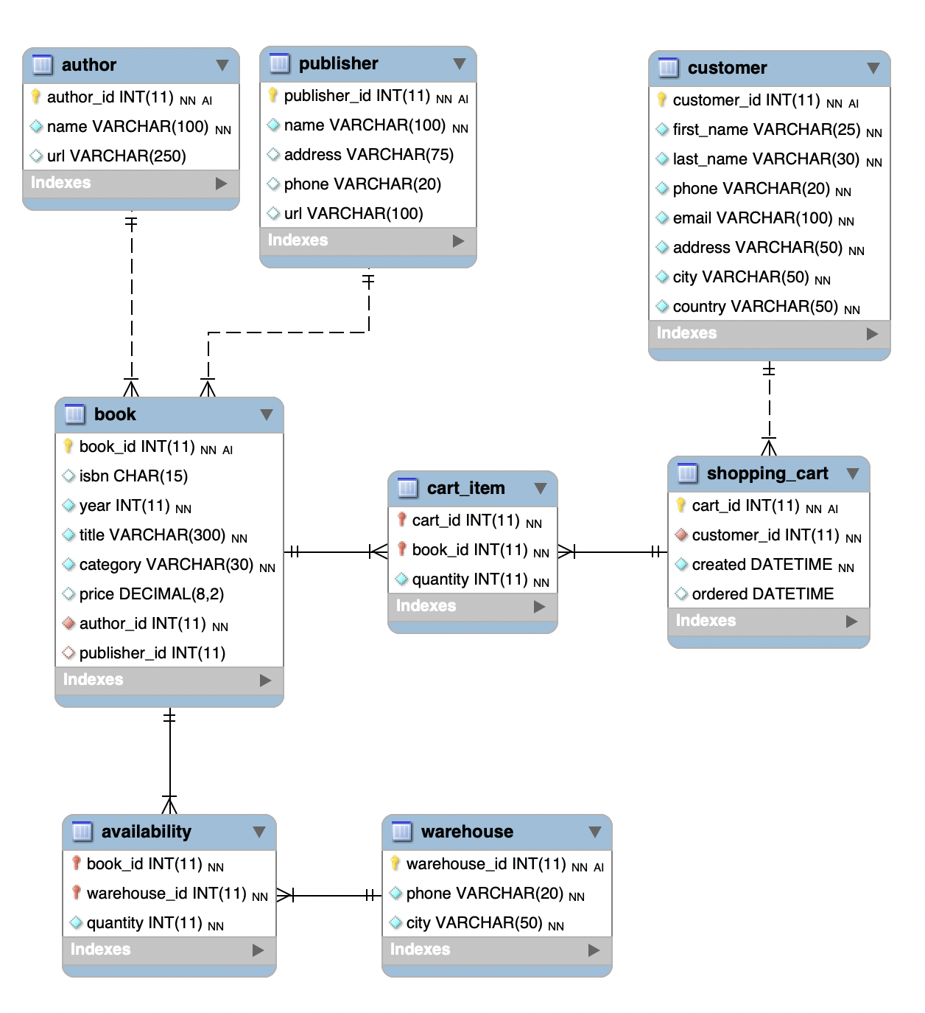

## Note

Some of the questions may require more than one SQL query to complete.

# Part 1 – With Instructor

## Question 1

Write a function that returns the number of books in the table with the author number 501.

## Question 2

Write a function that summarizes the number of books in the store that are published by publisher number 60, and publisher number 180. Make the result set header to be “publisher” and “quantity” (the numbers below are just examples, your data will be different:

## Question 3

Write a query that tells you how many authors had their books published by publisher

number 50. Make sure the result header to “total.”

## Question 4

Write one query that tells lists the author IDs who have exactly 6 books in the database.

## Question 5

Write a query that tells which customers have completed two orders. You will know that a shopping cart was ordered if the “ordered” field has a time recorded. The output of this query should be just the customer IDs.

## Question 6

Using a sub-query produce a list of the books titles whose publishers have a URL that ends with ‘.com’ and sort the output alphabetically from A to Z.

# Part 2 – Additional Exercises

## Question 1

List the warehouse id and the total number of books they have for the warehouse locations that have more than 120000 books in stock. Use the column headers warehouse and total_books

## Question 2

Update warehouse 2 to make ensure that any book they have with a quantity of less than 50, be increased by 100 copies. Then run the query from question 1 (part 2) above which should show both warehouses now.

## Question 3

Find how many books are in the book table that were never purchased. This will be a single number and requires a sub-query.

## Question 4

How many books has Llyod Rust purchased? The answer must use sub-querie(s). The query must also work for all cases for full marks.